PySpark

# Advantages

* Improves efficiency



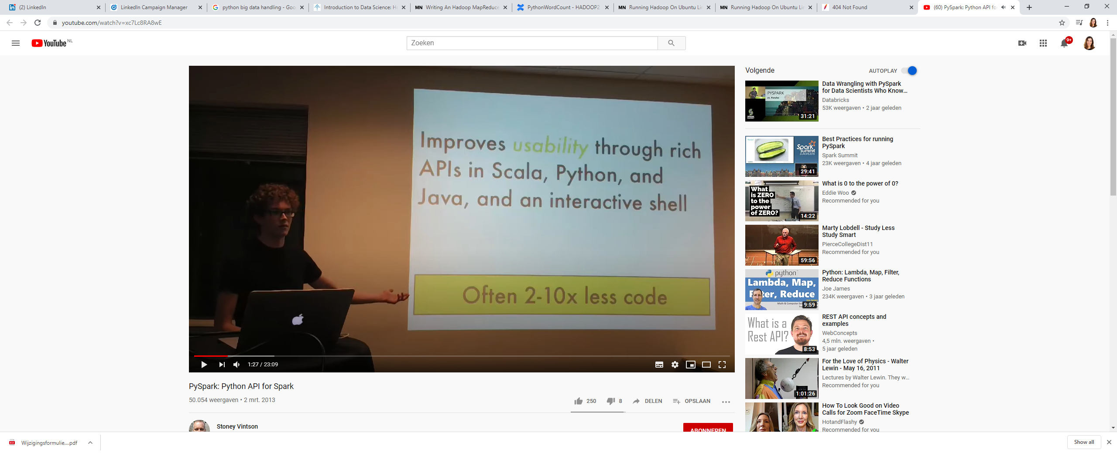



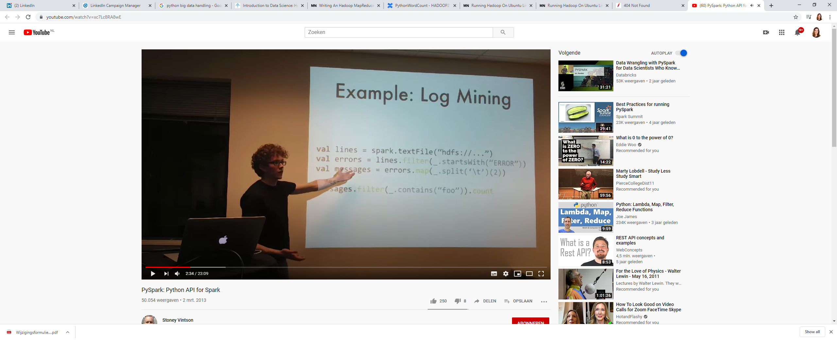

Errors are the lines that start with ‘ERROR’ and messages are the second field in those



Example of pyspark program

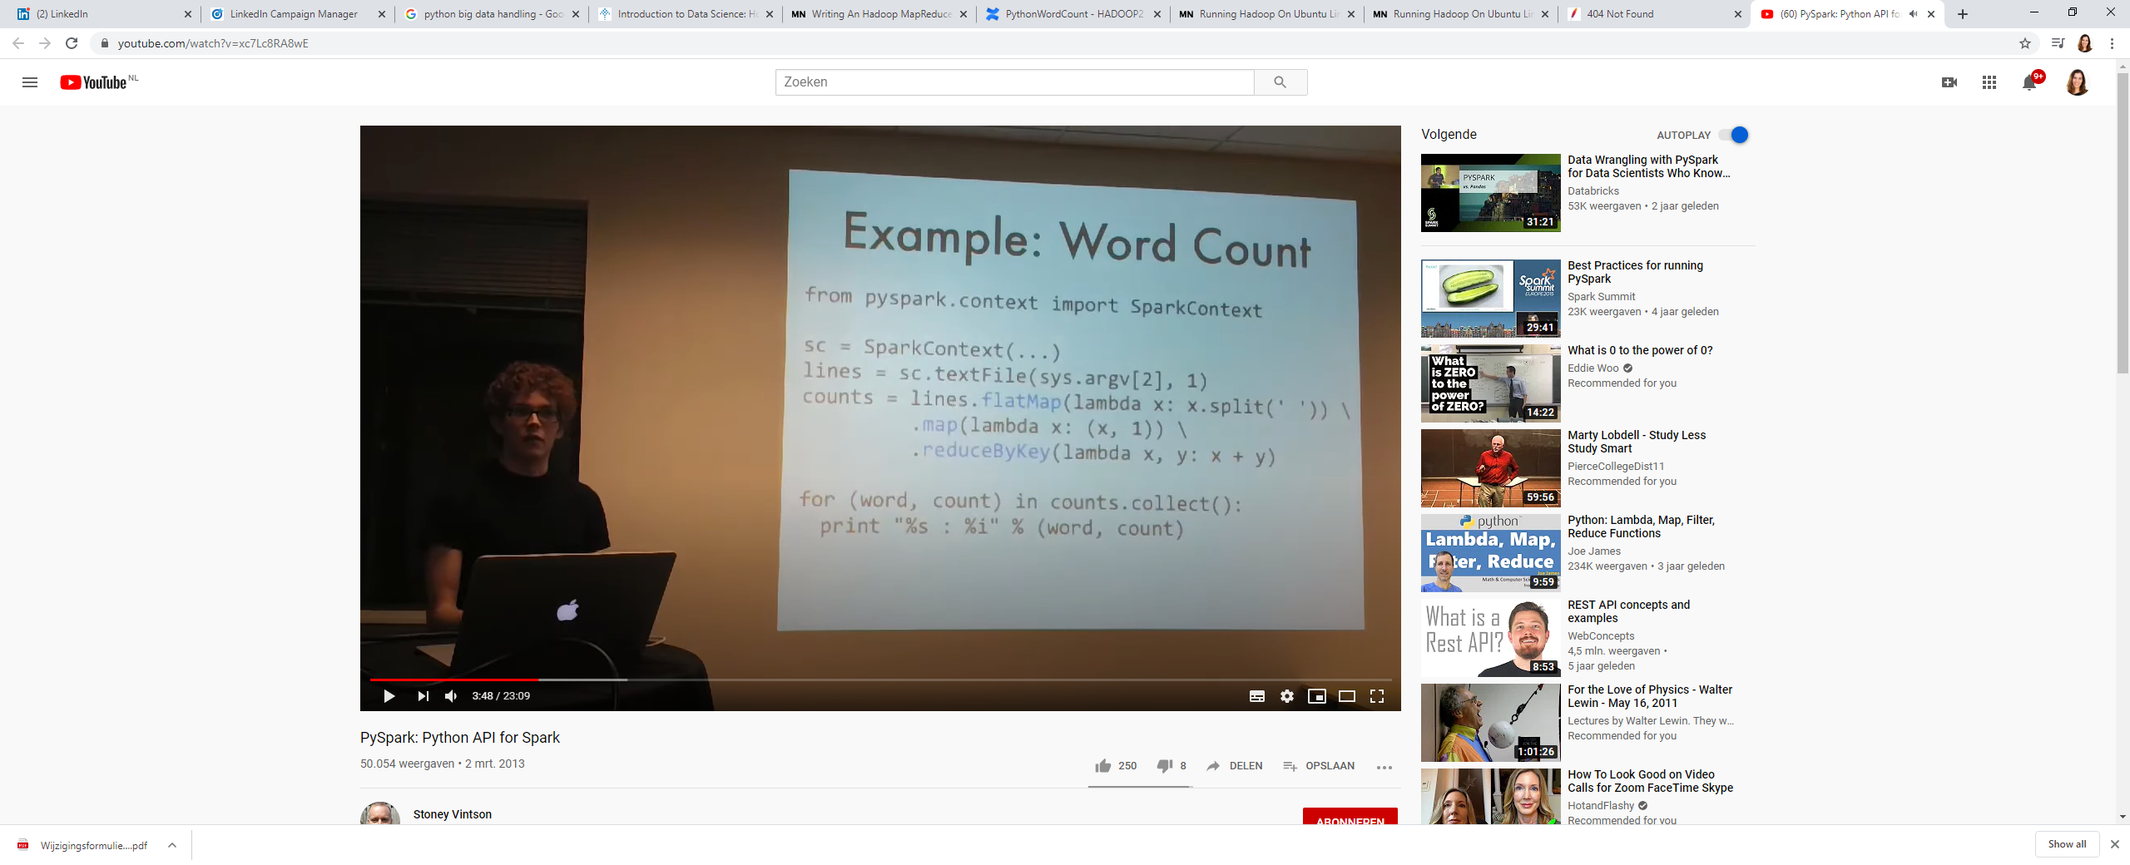

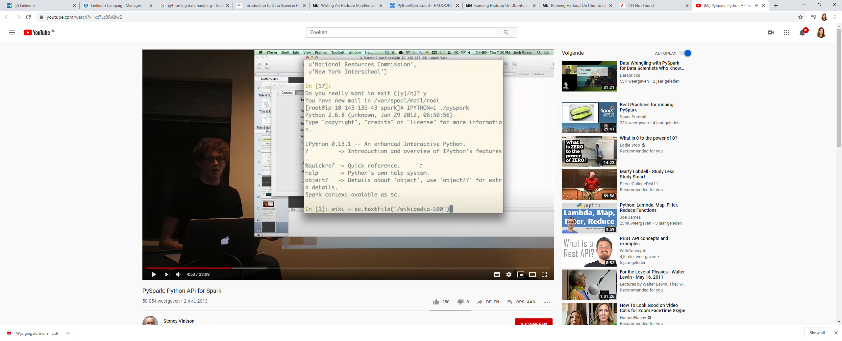

RDD = Resilient Distributed Dataset = immutable, partitioned collection of objects

To get out all Berkeley pages, filter here.

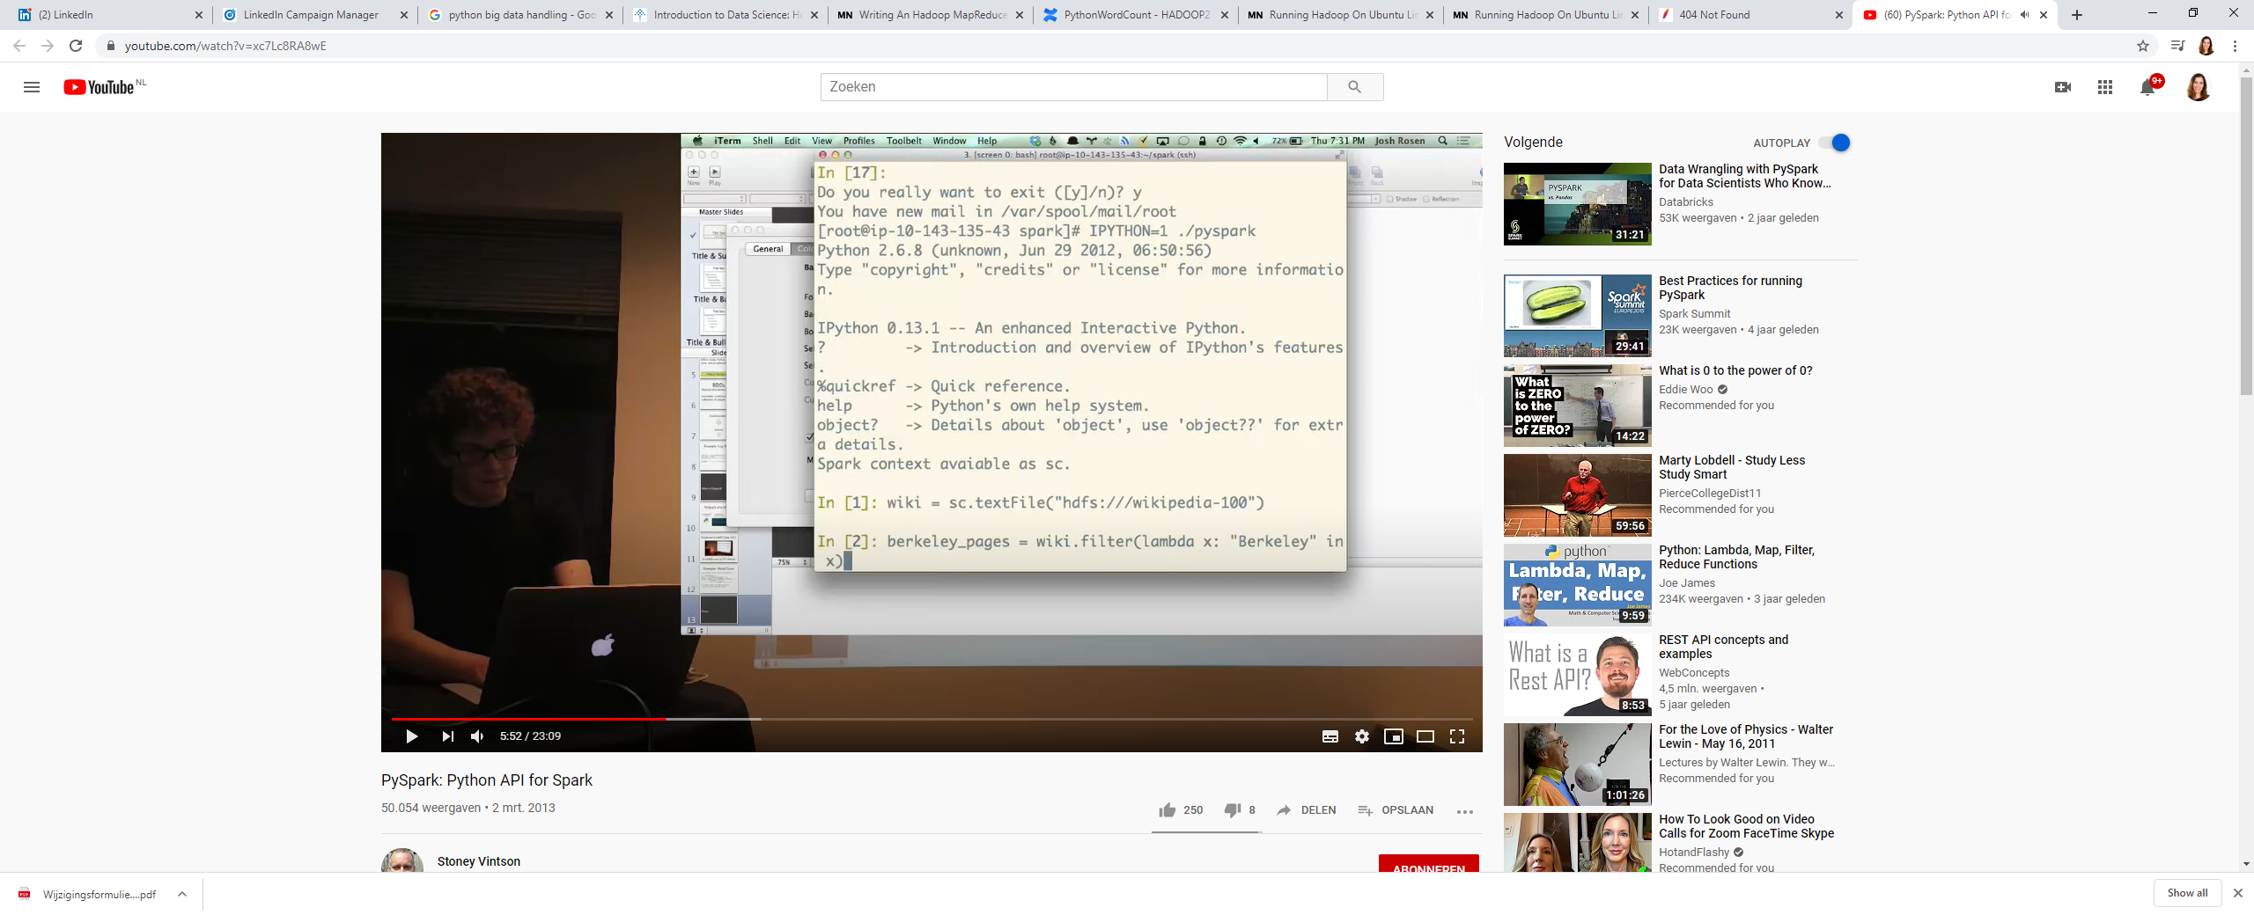

Use df.cache() to make sure that the dataframe is kept as is now (as RDD file)

To see how long it takes to count something, use %time before the function??



If you want to have all titles for example, you can map the dataframe like: df.map(lambda x: x.split(‘\t’)[1]) .first() / .take(100) # ‘\t’ i a tab and [1] as this is the second line (0-based) . take(number of samples to take) in stead of first().



KMeans clustering example using Numpy Arrays

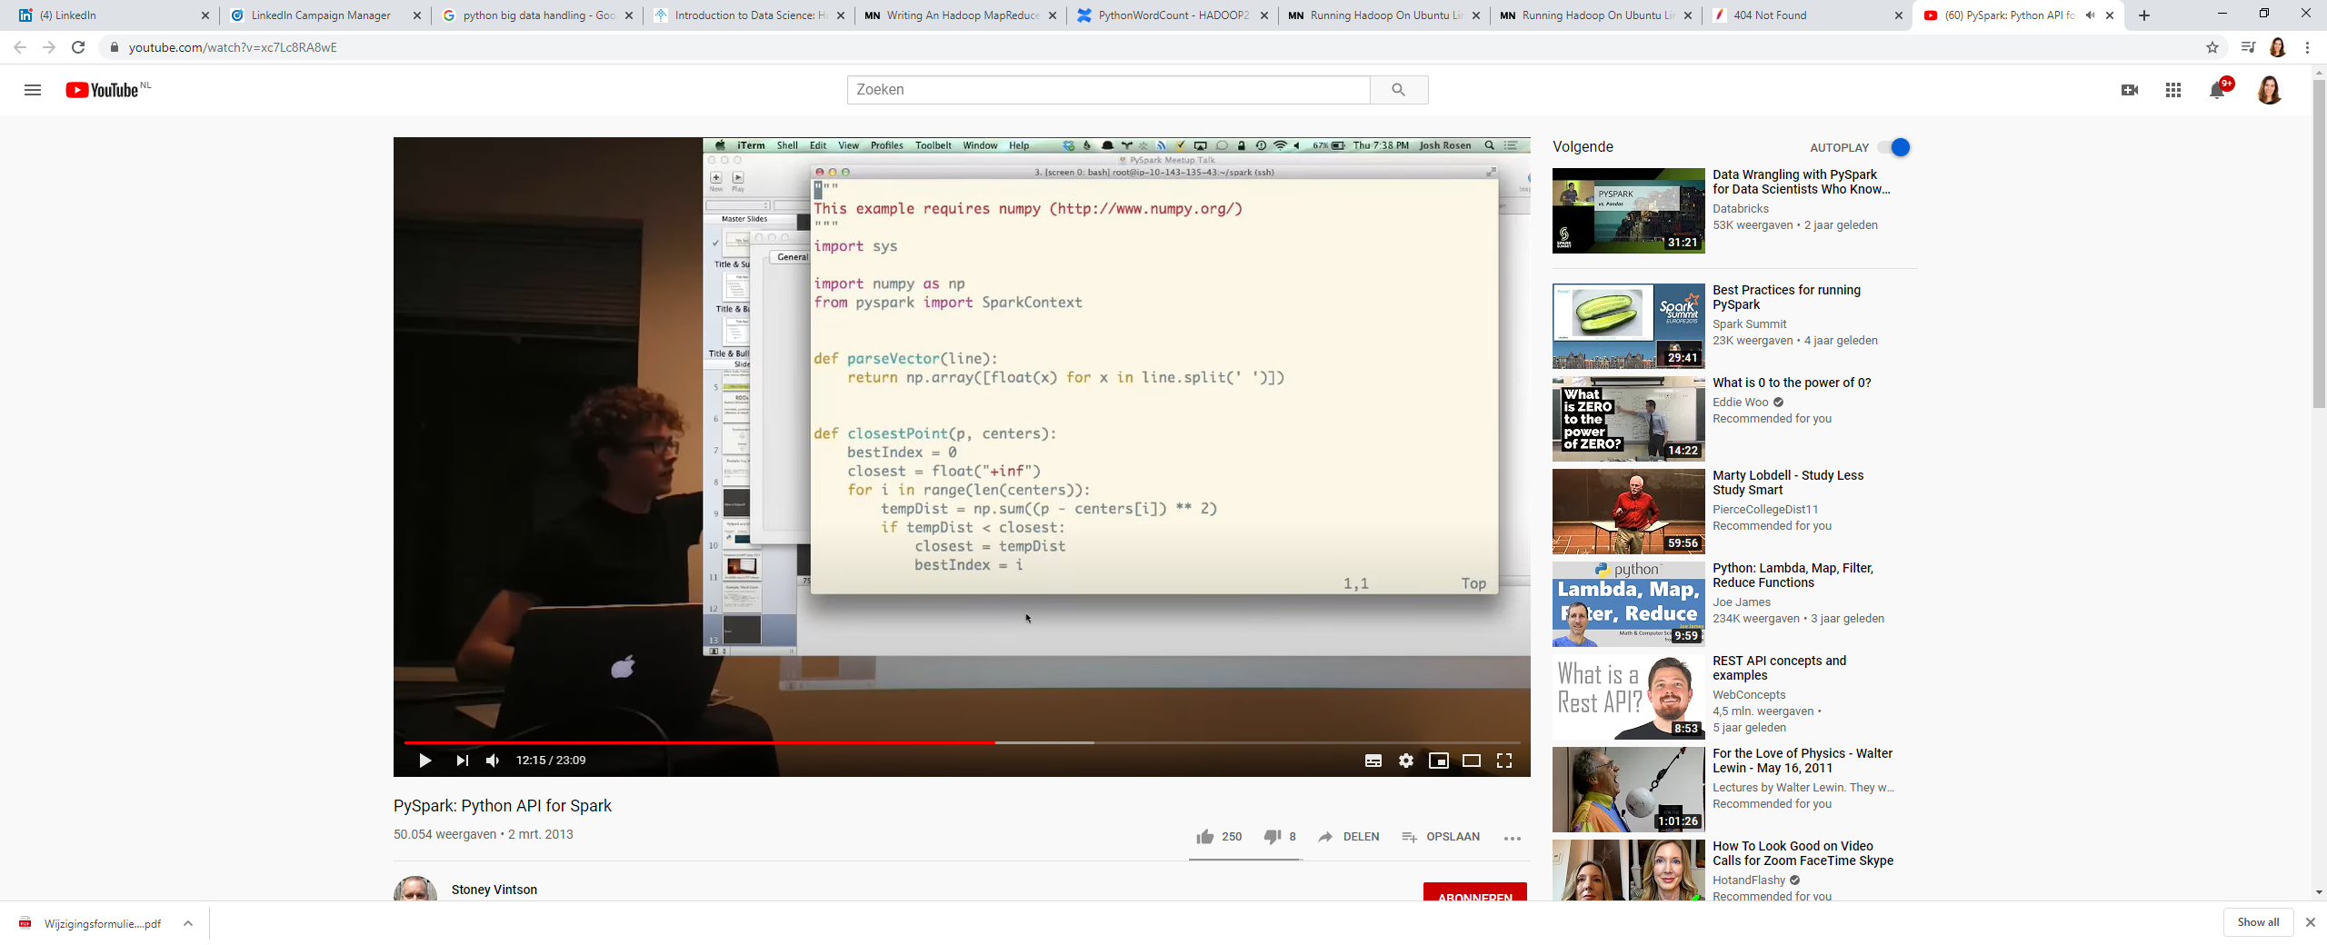

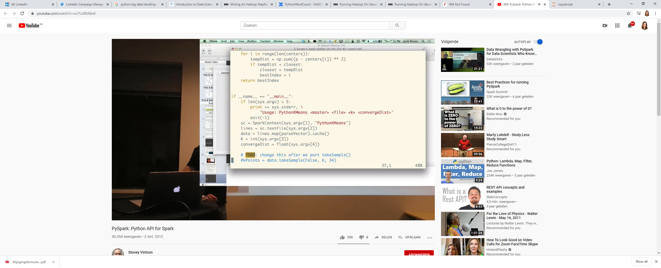

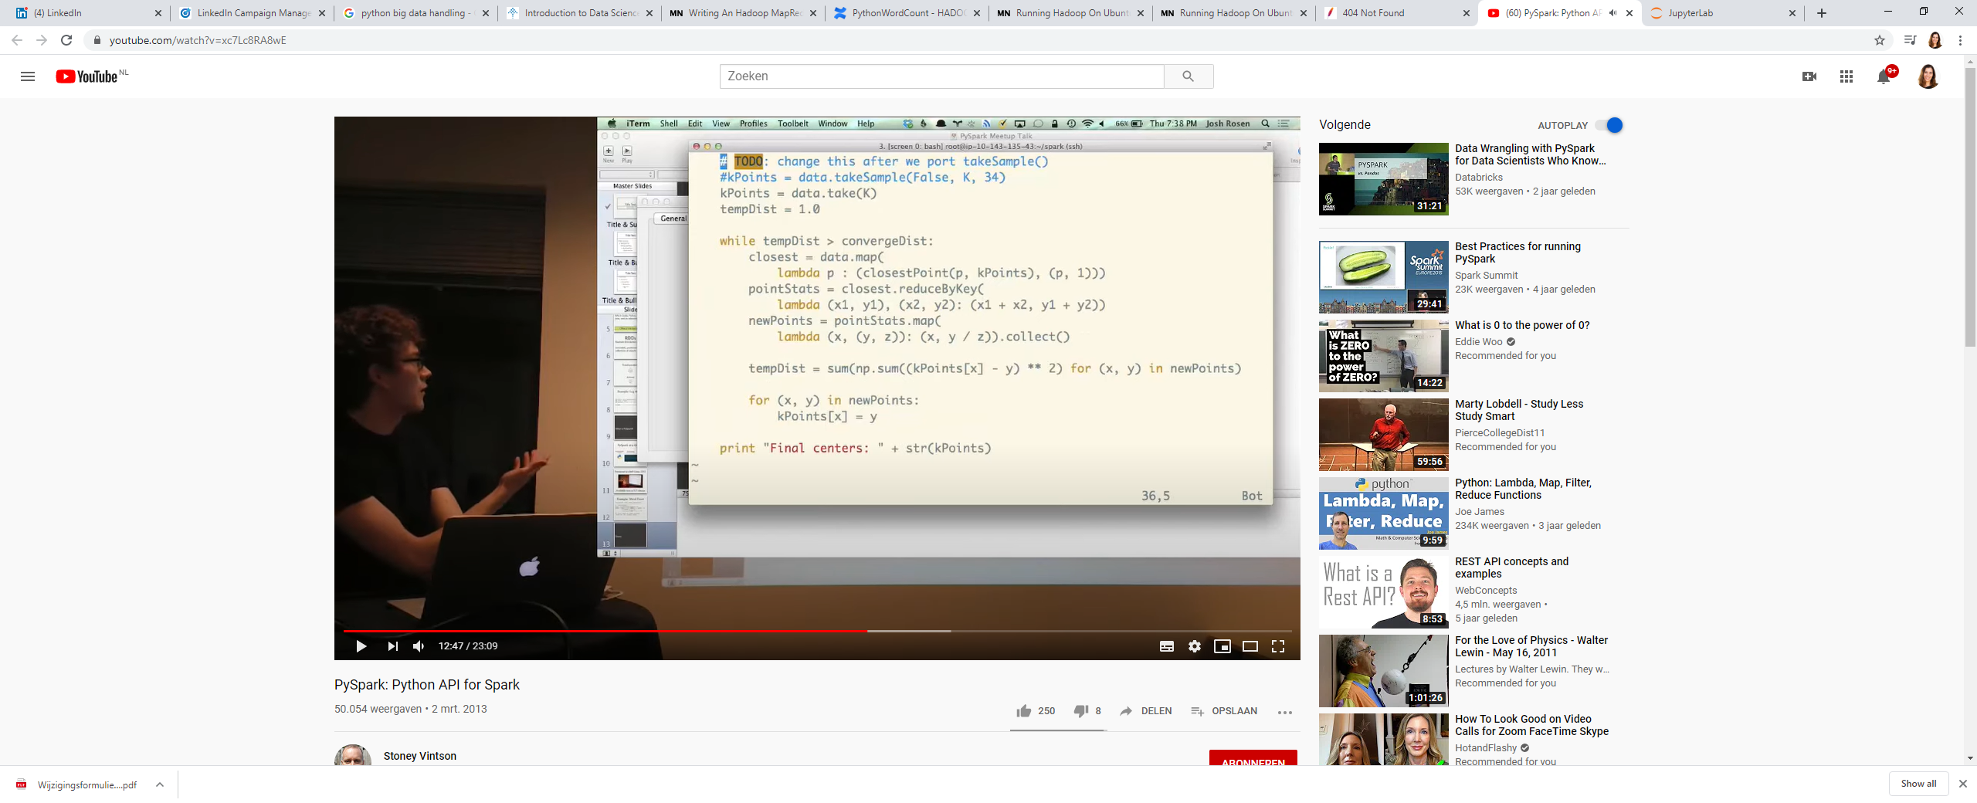

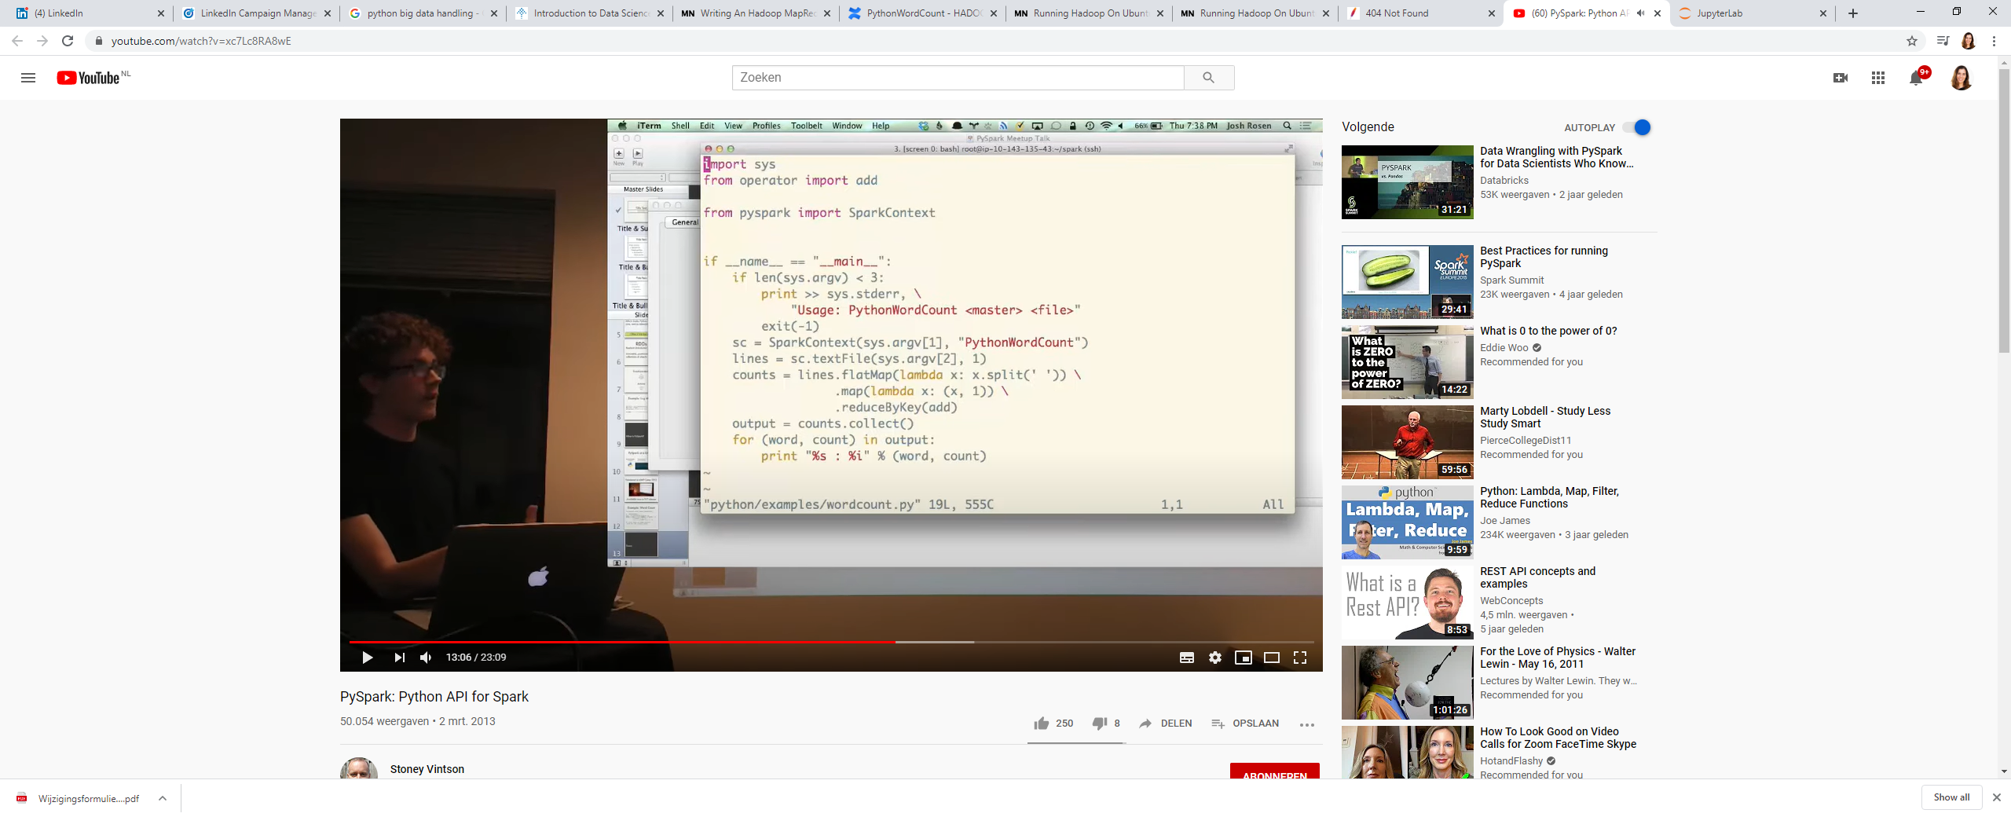

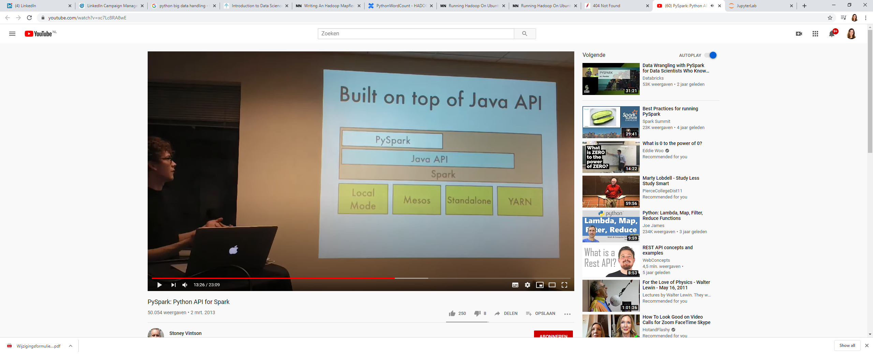

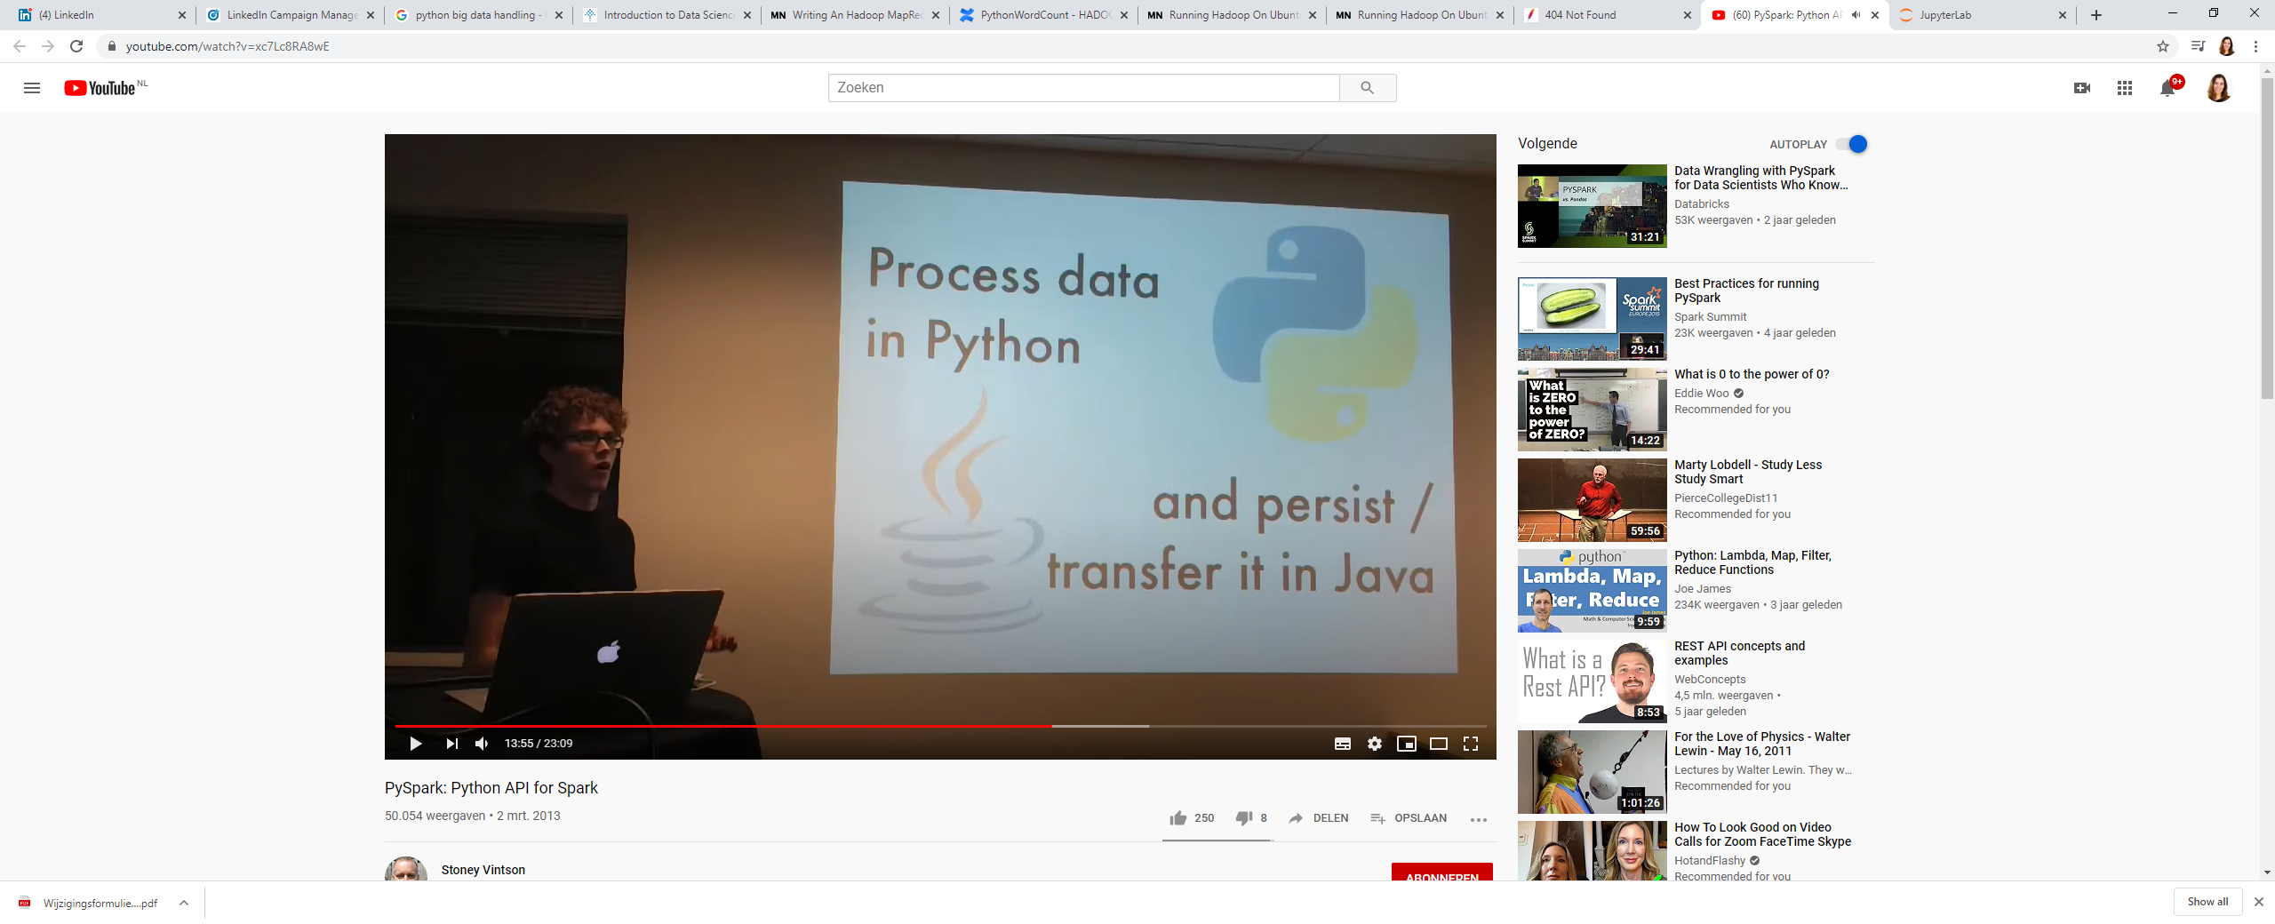

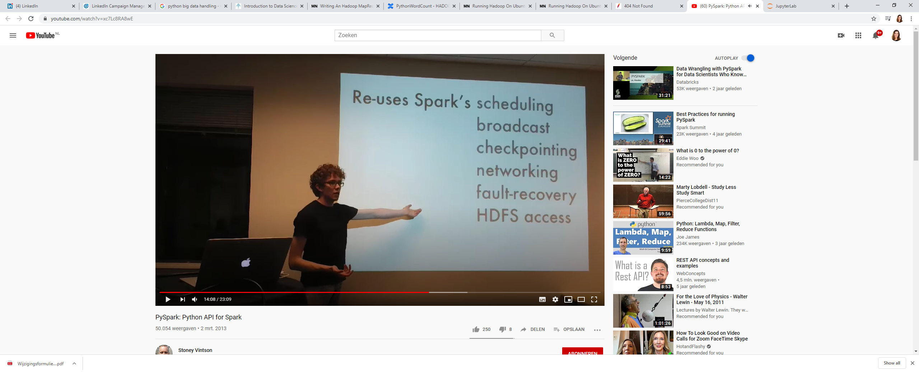

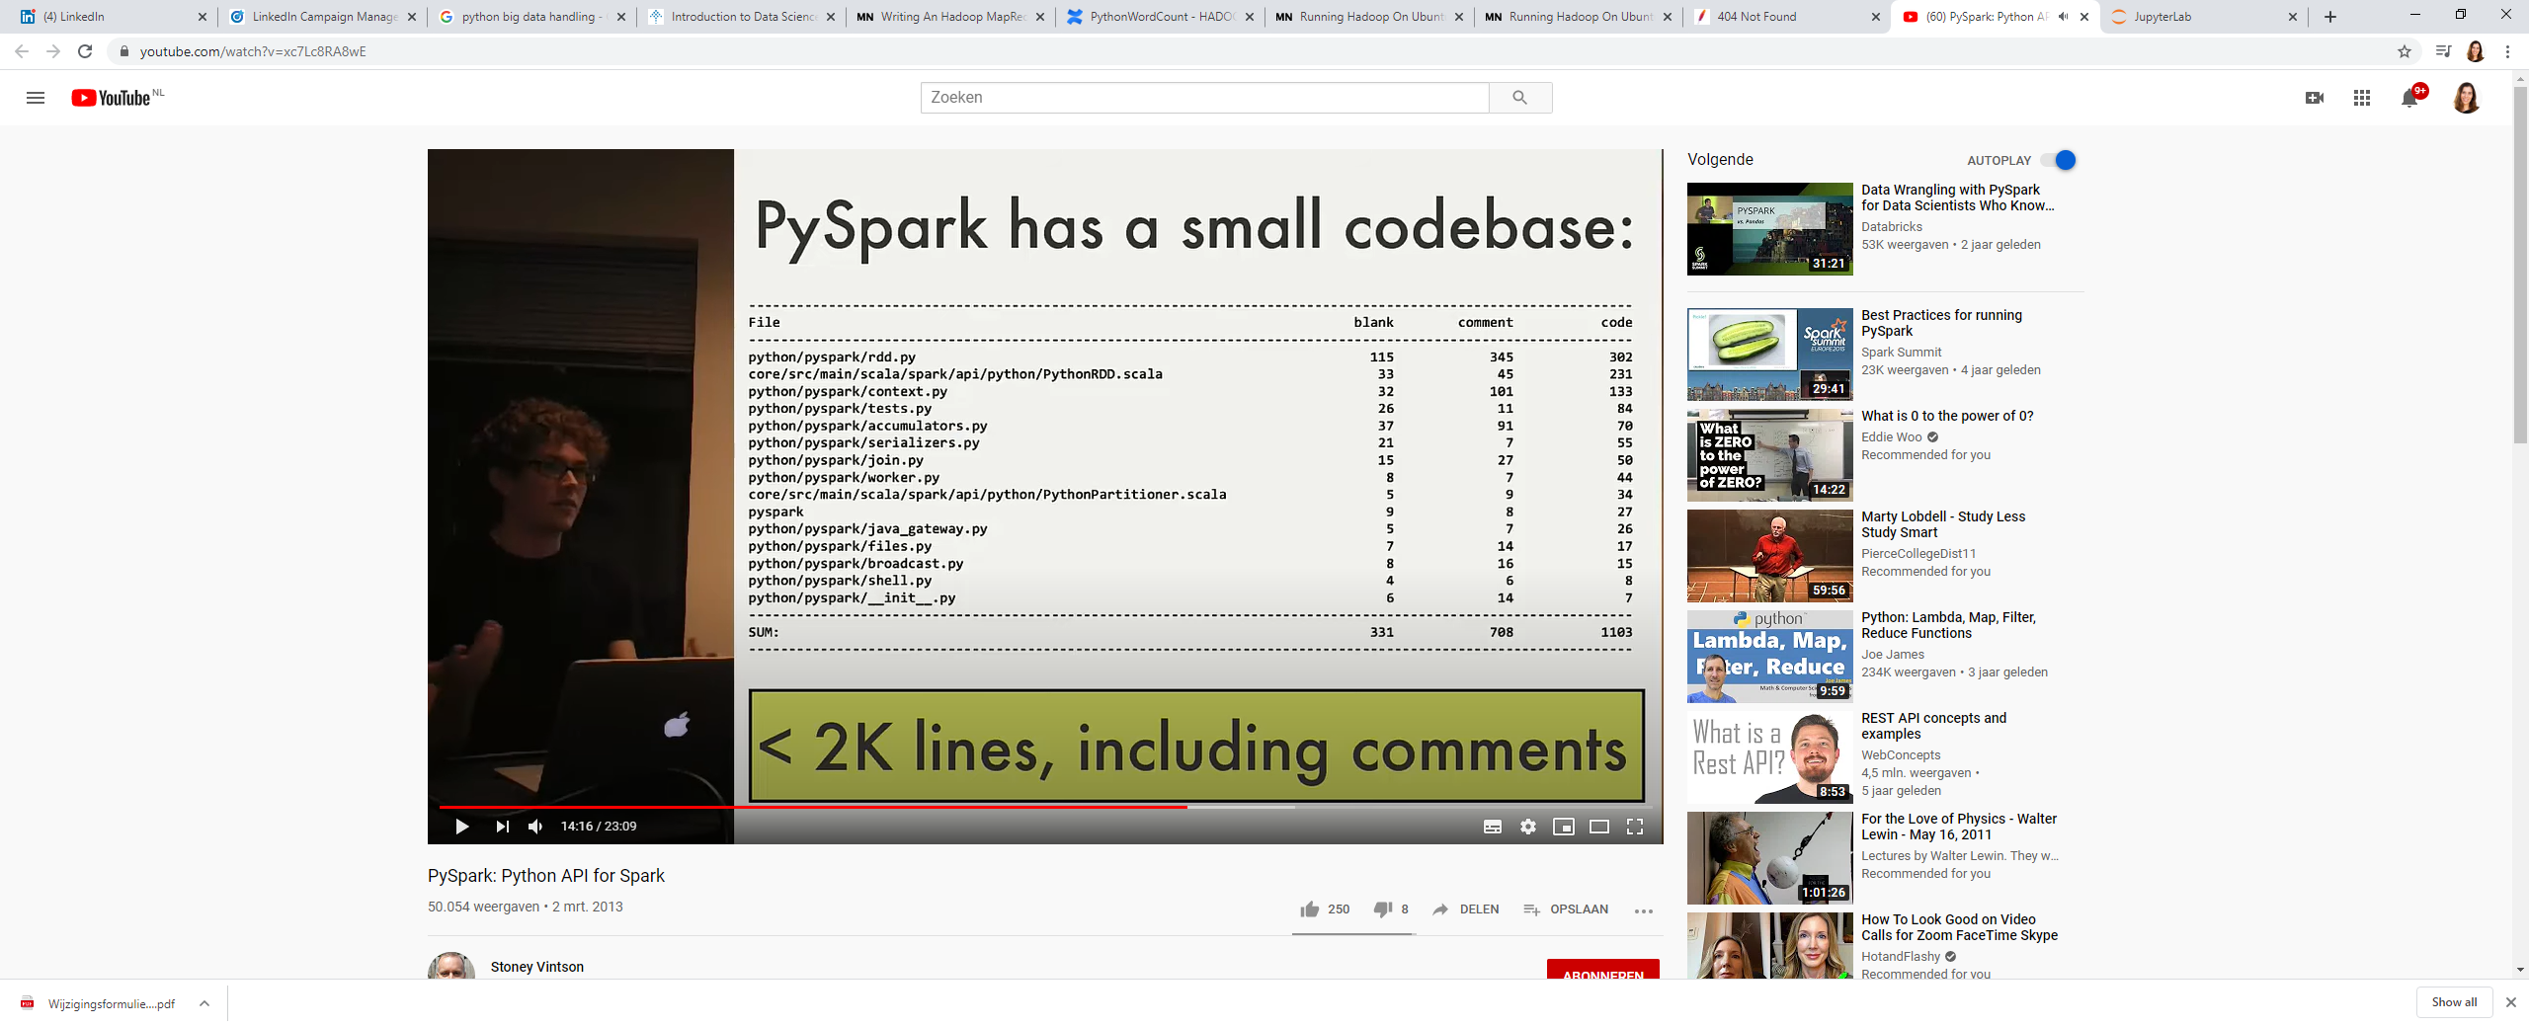

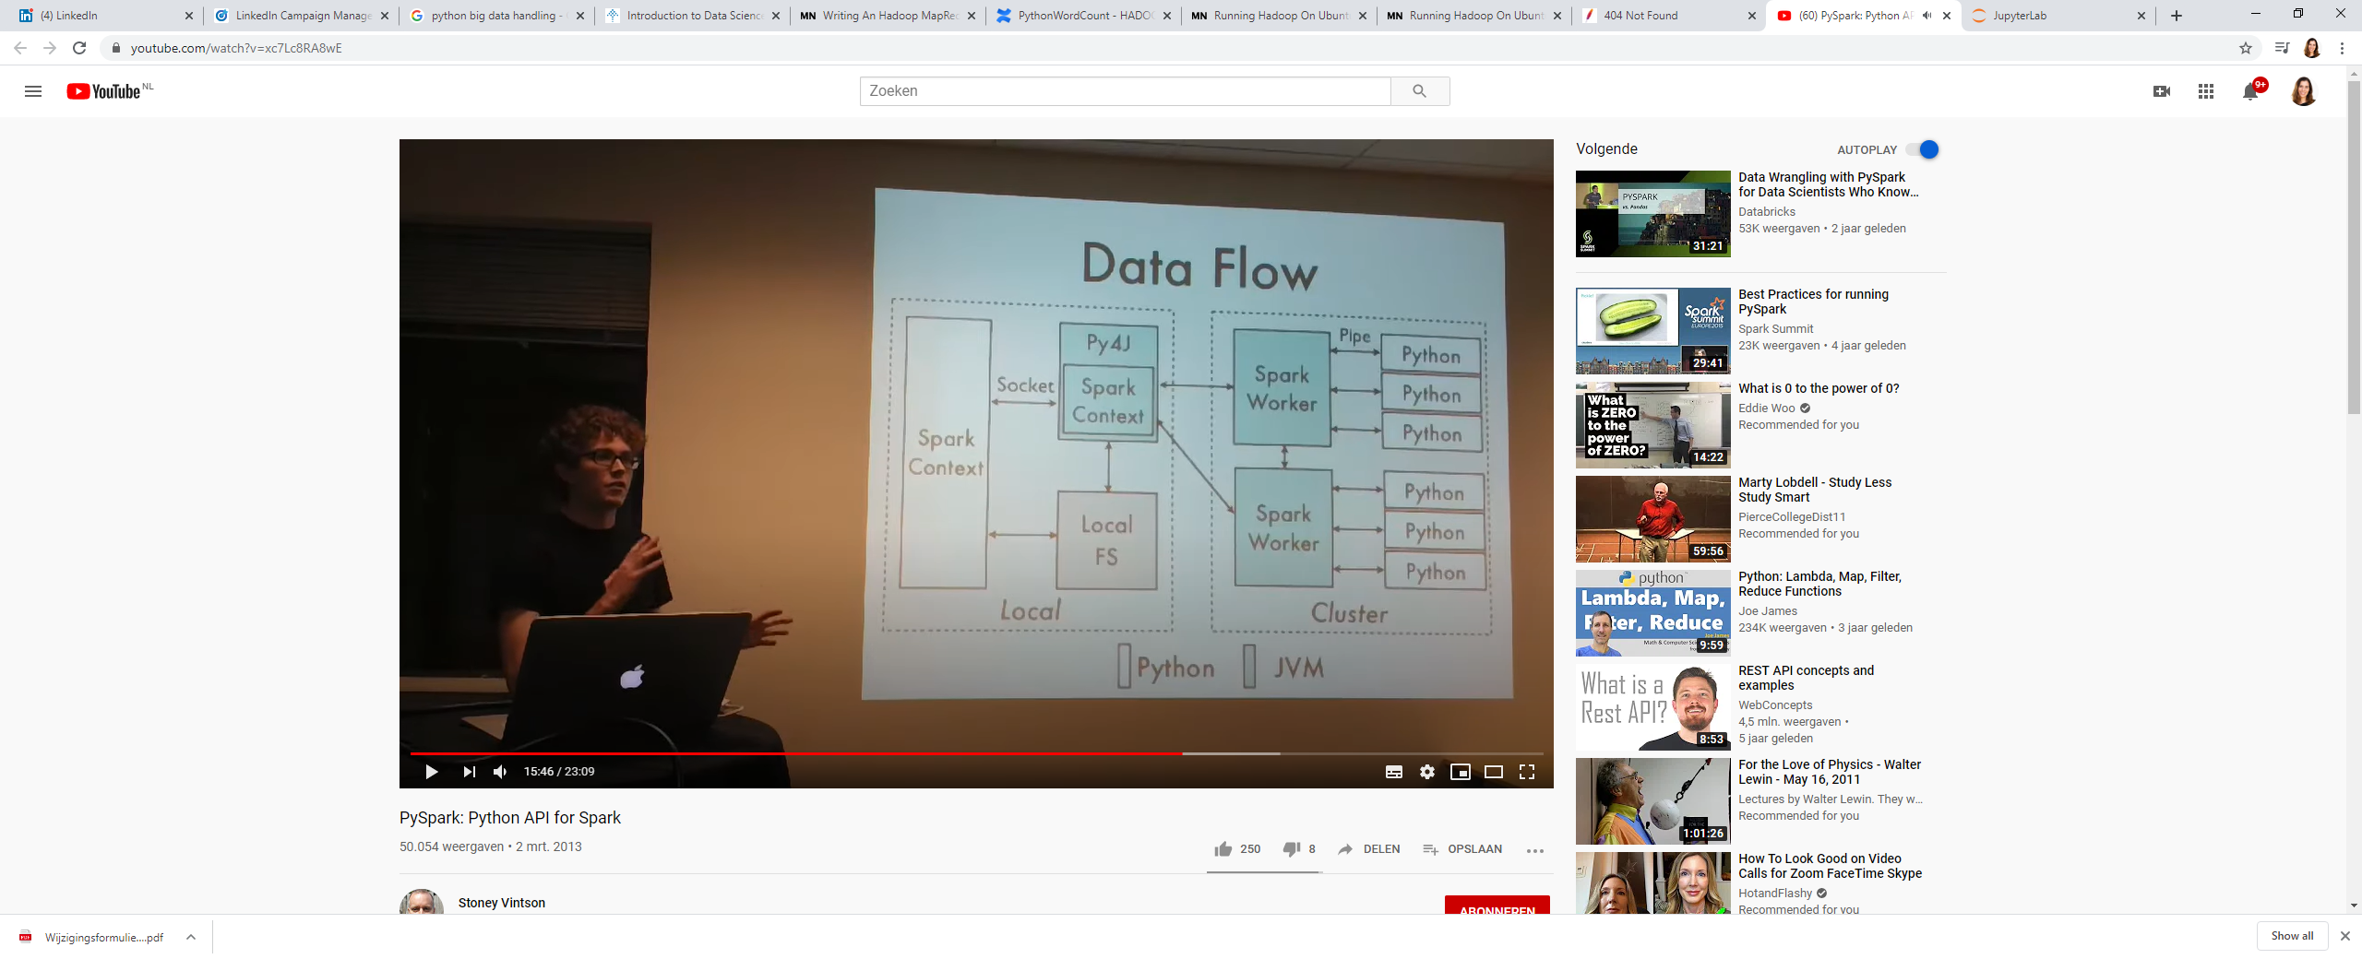

This avoids using Jython, as Jyhon does not support all libraries (such as Numpy).

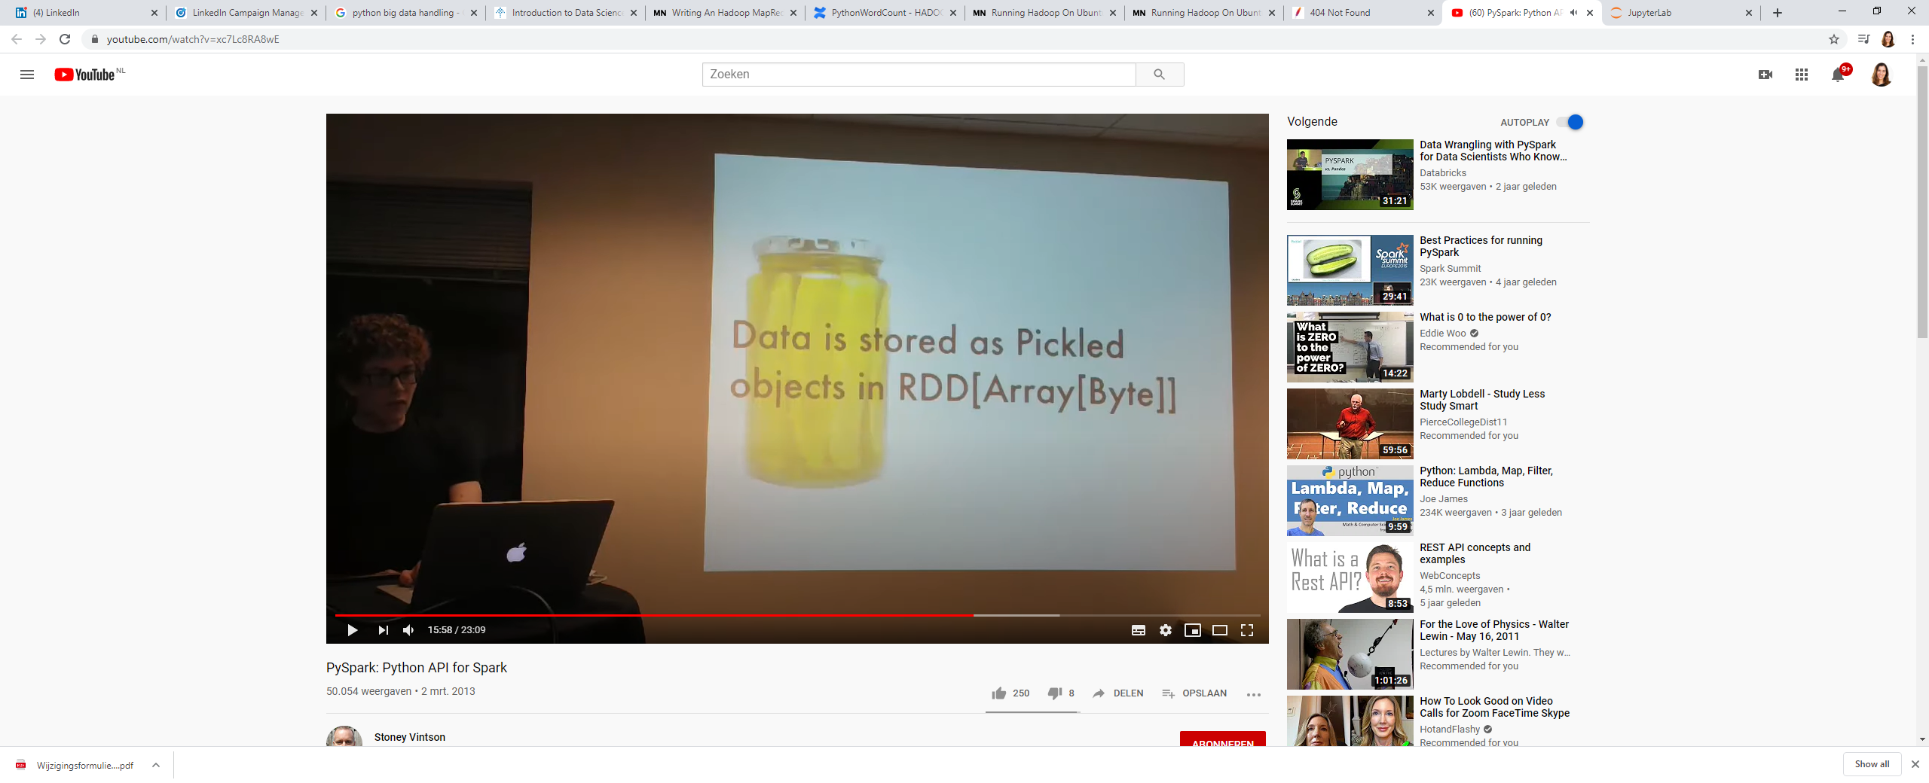

Python is named after Monty Python😉 and this storage is called pickle (this is to seriealize the data) and there is a persistence library called shelf.

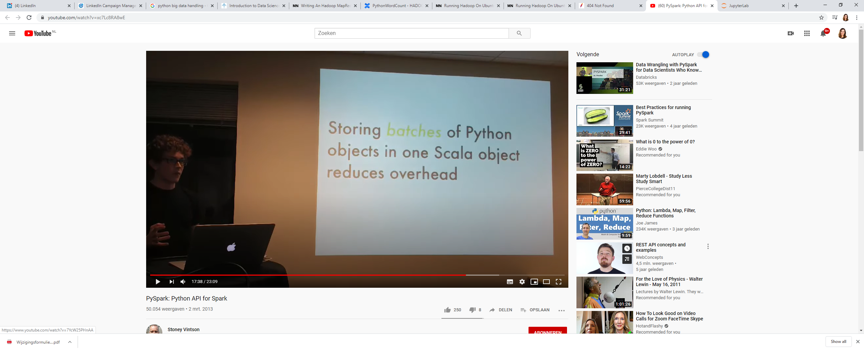

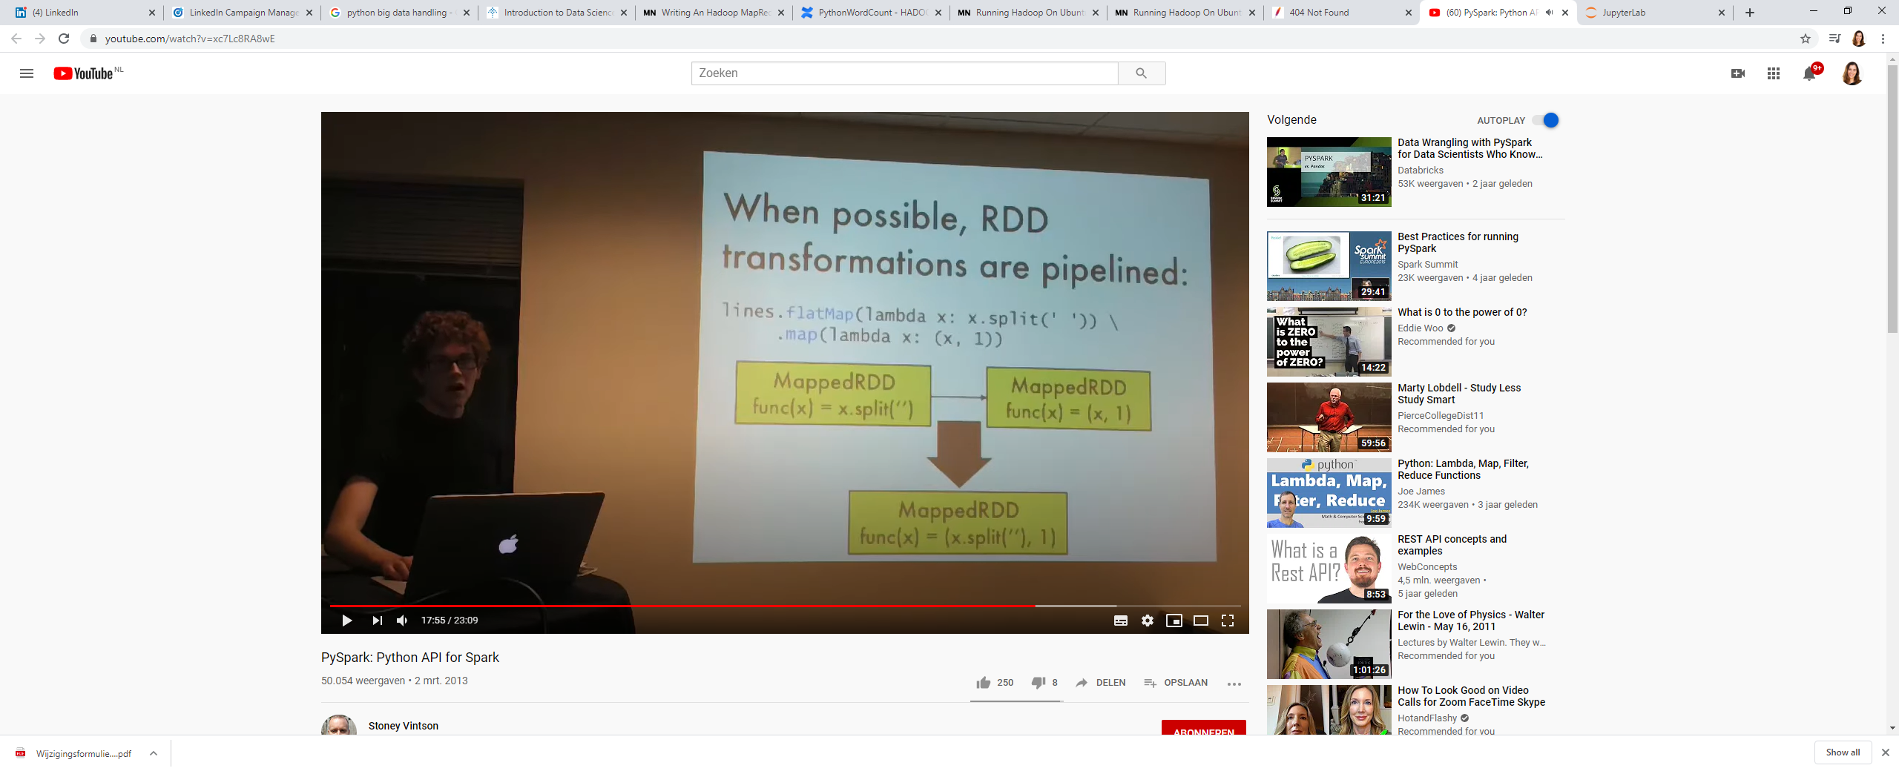

This means that the data steps are composed together in one function if possible and then run, rather than run the two steps separately.

